**Objective 2.05  Use recursively-defined functions to model and solve problems.**

1. Find the sum of a finite sequence.
2. Find the sum of an infinite sequence.
3. Determine if a given series converges or diverges.
4. Translate between recursive and explicit representations

|  |  |  |  |  |
| --- | --- | --- | --- | --- |
| **Day** | **Topic** | **Students will be able to:** | **Activity** | **Hwk – from textbook** |
| 2  Friday, 11/8 | 12.1 Sequences and Fibonnaci Sequence | Find particular terms of a sequence from a general term and use recursion formulas,  Find the common difference for an A.S., write terms of an A.S., use the formula for the general term of an A.S |  | Pages 825-826  #2-20 even  #34-40 even  #48-52even |
| 3  Tuesday 11/12 | 12.2 Arithmetic Sequences and Series | Find the common difference for an A.S., write terms of an A.S., use the formula for the general term of an A.S  Use the formula for the sum of the first “n” terms of an A.S. |  | Page 832  #8-34 even |
| 4  Wednesday,  11/13 | 12.1/12.2 Review | **QUIZ– 11.1/11.2** | “What is the Sun’s Other Job?” **worksheet** |  |
| 5  Thursday, 11/14 | 12.3 Geometric Sequences | Find the common ration of a G.S., write terms of a G.S., use the formula for the general term of a G.S. |  | Page 839  #1-22 |
| 6  Friday,  11/15 | 12.3 Geometric Sequences and Series | Use the formula for the sum of the first n terms of a G.S and use the formula for the sum of an infinite G.S. | **Worksheet:** “What do you call spooky sausages?” | Page 840-841  #23-30  #37-44 |
| 7  Monday,  11/18 | 12.3 Review  12.4 Applications | **QUIZ– 11.1/11.3** |  | Page 832 #35-43  Page 840 #31-35  Page 841 #51-52 |
| 8  Tuesday,  11/19 | 12.1-12.4  **Review** | Exploring where geometric and arithmetic sequences are used in the real world. | Textbook:  Pg. 868-869  #1-60  Selected problems |  |
| 9  Wednesday,  11/20 | **TEST** | **Show mastery on arithmetic sequences and series! ☺** | **TEST** |  |

Day 1: 12.1 Notes

Example of a **sequence**: 2, 4, 6, 8, …2n each number in the sequence is called a ______ of the sequence.



**Finite Sequence**: function whose domain is the set of positive integers less than or equal to some fixed positive integer.

**Infinite Sequence**: function whose domain is the set of all positive integers.

**Example 1:** List all of the terms in the *finite* sequence.

a) for  b) a=for 

**Example 2**: List the first three terms of the *infinite* sequence whose nth term is .

**Example 3:** Find the first five terms of the sequence defined recursively by and .

**Fibonacci Sequence** named after the Italian mathematician who used it to solve a problem about the breeding of rabbits. This sequence also occurs in numerous other applications in nature

$$F_{n}=F_{n-1}+F_{n-2}$$

**Example**: Find the first 11 terms of the Fibonacci Sequence given that $F_{1}=1$ and $F_{2}=1$

**Partial Sums of a Sequence**

For a sequence $a_{1}, a_{2}, a_{3}…a_{n}…$ the _______________________ are

$S_{1}=$

$S_{2}=$

$S_{3}=$

$S_{4}=$

$S_{n}=$

$S_{1}$ is called the _______________________, $S_{2}$ is called the _______________, and so on. The sequence is called _________________________.

**Example:** Find the first four partial sums and the nth partial sum of the sequence given by $a_{n}=({\frac{1}{2})}^{n}$

**Example:** Find the first four partial sums and the nth partial sum of the sequence given by $a_{n}=\frac{1}{n}-\frac{1}{n+1}$

**Sigma Notation:** We can write the first n terms using _____________________________ or ______________________.

$$\sum_{k=1}^{n}{a_{k}}=a_{1}+a_{2}+a_{3}+…+a_{n}$$

**Example:** Find each sum

$\sum_{k=1}^{5}{k^{2}}$

$\sum_{k=3}^{5}{\frac{1}{j}}$

**Example:** Write each sum using sigma notation

$1^{3}+2^{3}+3^{3}+4^{3}+5^{3}+6^{3}+7^{3}$

$\sqrt{3}+\sqrt{4}+\sqrt{5}+…+\sqrt{77}$

**Properties of Sums:**

$\sum_{k=1}^{n}{{(a}_{k}{+b}_{k})=}$

$\sum_{k=1}^{n}{{(a}_{k}{-b}_{k})=}$

$\sum_{k=1}^{n}{{ca}_{k}=}$

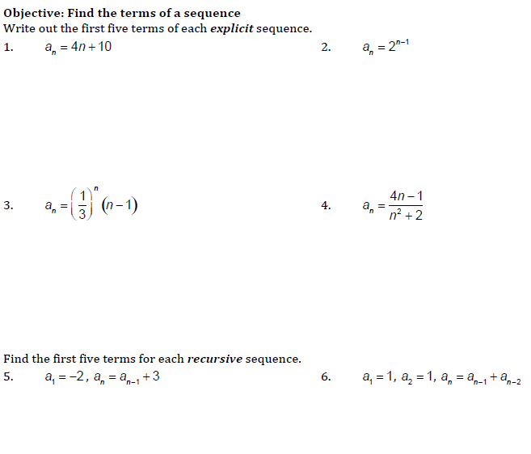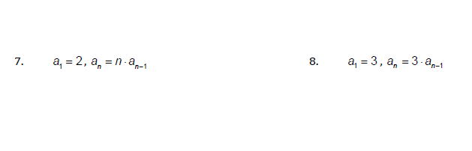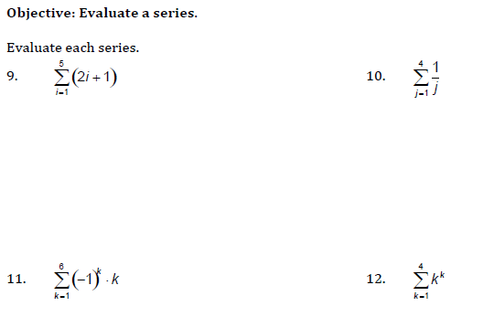

12.2 Notes

**Arithmetic Sequence** is a sequence of the form:

 nth term 

first term common difference

**Example 1:** Are the following arithmetic sequences? If so, find d.

1. 2, 5, 8, 11, …
2. 9, 4, -1, -6, -11, …
3. 2, 5, 9, 14, 20, 27, …

**Example 2:** Find the common difference for each arithmetic sequence.

* 1. b)

**Example 3:** You can find the nth term by just knowing the first two terms:

1. 3, 1, -1, -3, -5, … What is our first term? _____ What is d? _____ nth term: __________________
2. 4, 7, 10, 13, 16, … What is our first term? ___________ What is d? ________

therefore, n term: ____________________ Now find the 20th term: _________________

**Example 4:** Finding terms of an Arithmetic Sequence:

a) Find the common difference if the first term is 13 and the 100th term is –581.

 Now solve for d:



1. Find the twelfth term of the arithmetic sequence whose first term is 2 and whose fifth term is 14.

 Now solve for d: Finally, solve for 12th term:



c) 11th term is 52, 19th term is 92, find 100th term

 =

 =

**Recall: Sigma Notation:** is the sum of the first five terms of the sequence read “the sum of n for n between 1 and 5, inclusive” (n is called the *index of summation*)

**Example 1**: Evaluate

a.  b. 

**Arithmetic Series:**

**Example 1:** Finding a Partial Sum of each Arithmetic Series:

For the arithmetic sequence , the nth partial sum is given by:

|  |  |
| --- | --- |
| * 1. Find the sum of the first 40 terms 3 + 7 + 11 + 15 +… | * 1. Find the sum of the first 50 odd numbers. |
| c) Find the sum of the series 12 + 16 + 20 + … + 84. |  |

**Example 2:** An amphitheater has 50 rows of seats with 30 seats in the first row, 32 in the second, 34 in the third, and so on. Find the total number of seats.

a= d= 50 rows, so n = 50

**Arithmetic Series Practice**

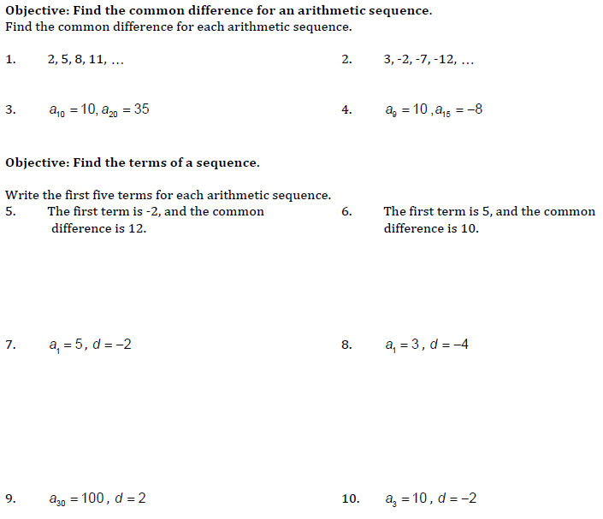

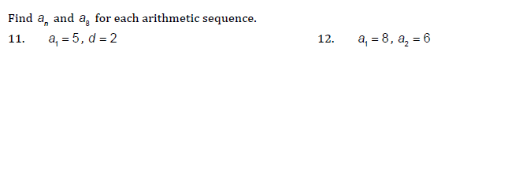

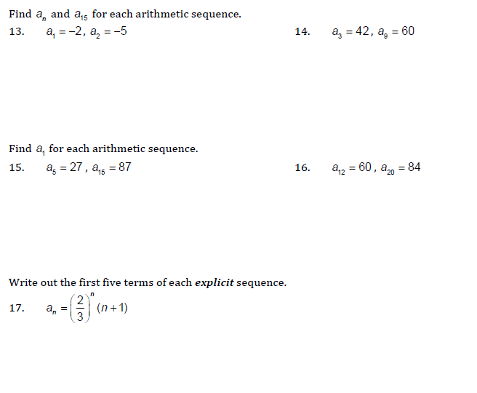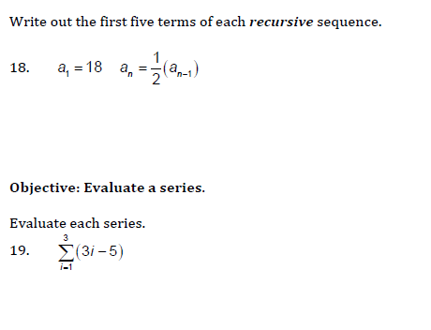

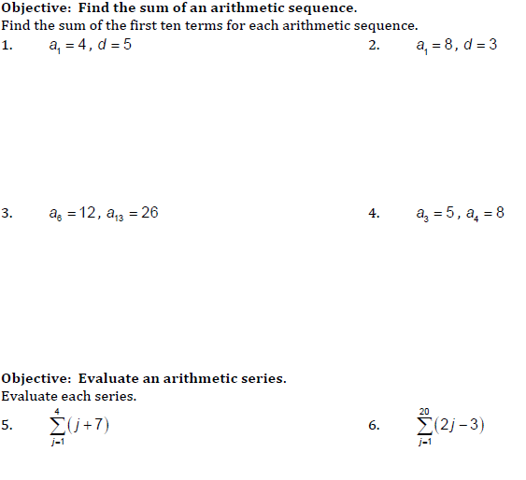

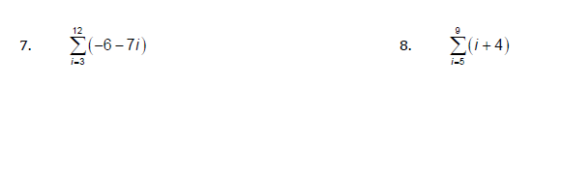

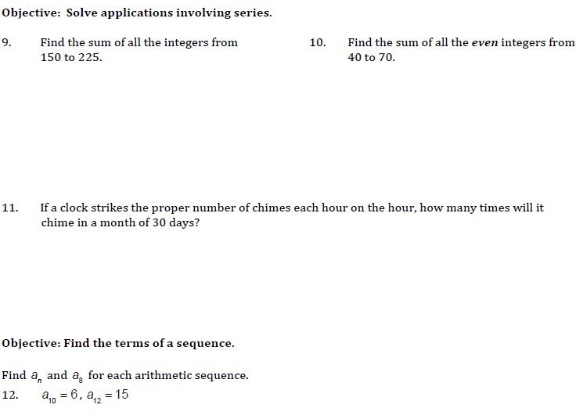

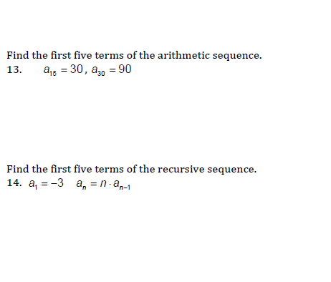

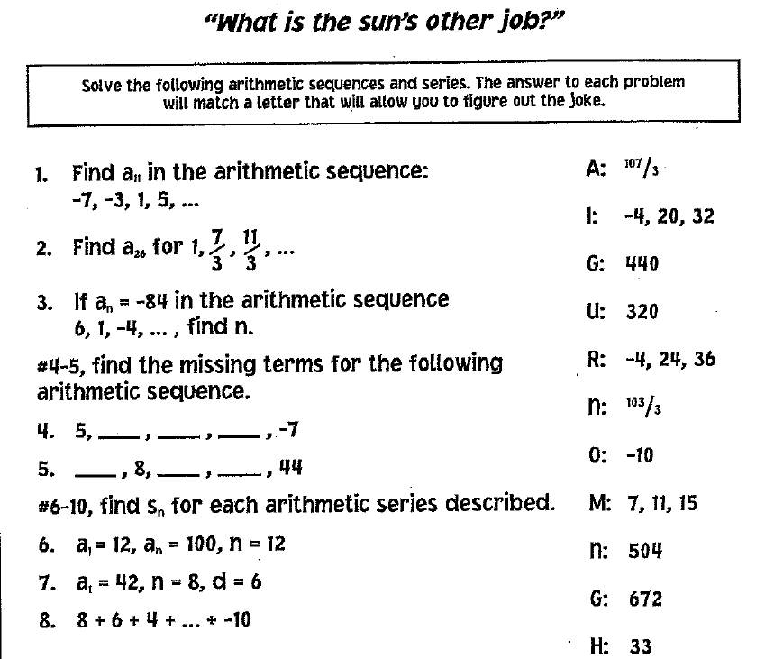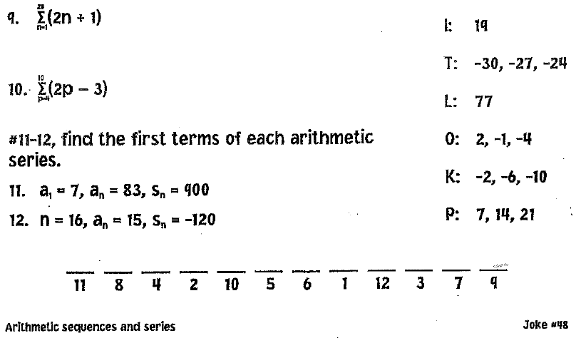

12.3 Geometric Sequence

**Geometric Sequence**: A sequence in which each term after the first is obtained by *multiplying* the preceding term by a constant (common ratio, *r*).

Geometric Sequence is a sequence of the form:

$a_{1}, a_{1}\left(r\right), a_{1}{(r)}^{2}, a_{1}{(r)}^{3}$, etc. where the nth term is: $a_{n}=a_{1}{(r)}^{n-1}$

Example of a Geometric Sequence: 3, 6, 12, 24, 48, … where r = 2



**Example 1**: Write the first five terms of the geometric sequence whose term is:

**Example 2:** Are these geometric sequences? If yes, what is the common ratio?

1. 5, 10, 20, 40, …
2. 27, 9, 3, 1, …
3. 2, 4, 12, 48, …

**Example 3**: Write a formula for the term of the geometric sequences and use that to find a10:

a)  b) 

 

Find r: Find r:

 

**Example 4:** Find the first term of a geometric sequence whose and whose *r* = ½.

**Example 5:** If the first term of a geometric sequence is $-\frac{2}{3}$ and $a_{5}= -\frac{32}{243}$, find the common ratio.

**Example 6:** Which term of the sequence 13, 26, 52, … is 832?

**Geometric Sequences Practice**

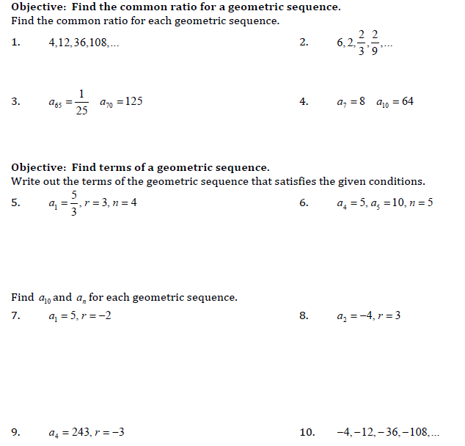

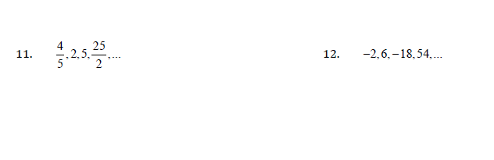

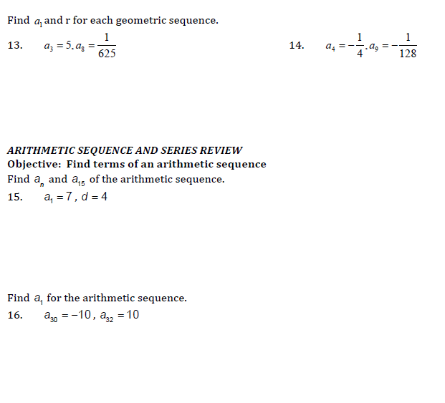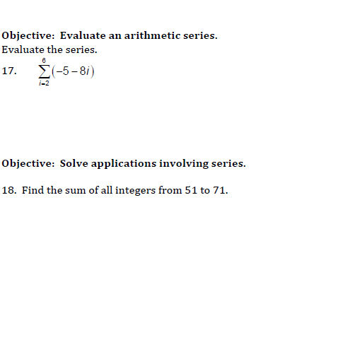

12.3 Geometric Series

**Finite Geometric Series**: The sum of a finite geometric sequence. Formula: $s_{n}=a_{1}\left(\frac{1-r^{n}}{1-r}\right)$

**Example 1:** Find the sum of the first 15 terms of the sequence 5, -15, 45, -135, …

**Example 2:** Find the sum of the series 

**Example 3:** Find the sum of the series, S = 1 + 2 + 4 + 8 + 16 + …+ 512

*What do you know? What do you need to use the formula above? Break it down into parts.*

**Example 4:** Find the sum of the series, S = 

**Infinite Geometric Series:** If is an infinite geometric series with , then the sum S of all of the terms of this series is given by:

*(Think about it, from the finite series summation . If , this is a small number getting smaller and smaller as n gets bigger. Therefore, we end up with in the numerator and 1- r in the denominator.)*

**Example 1:** Find the sum of the infinite geometric series.

a)  b) 

**Geometric Series Practice**

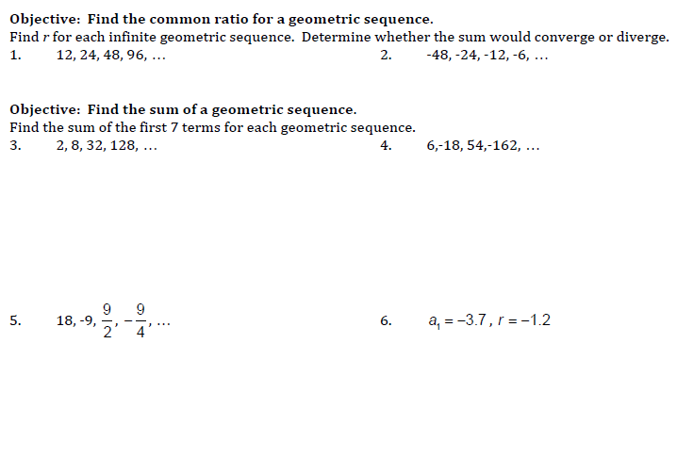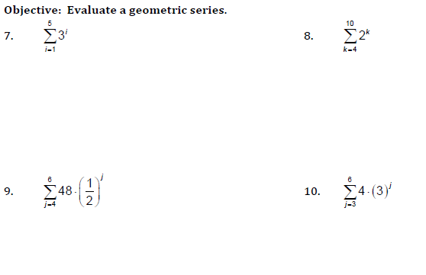

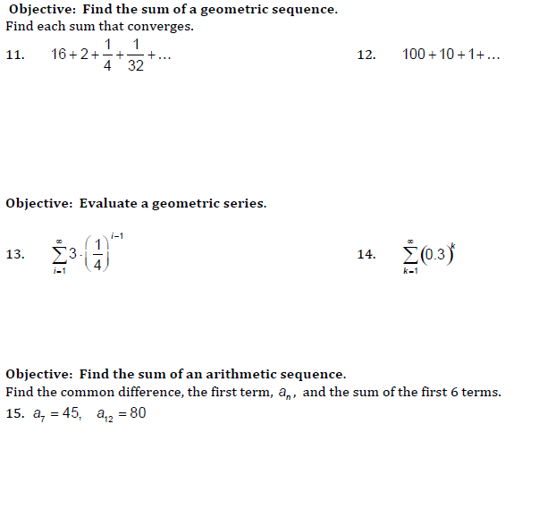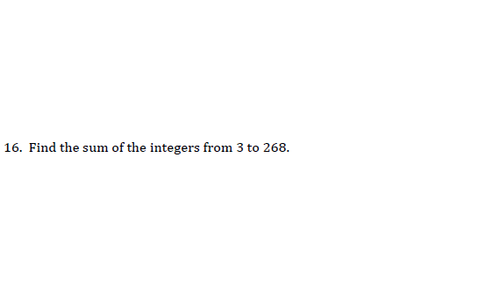

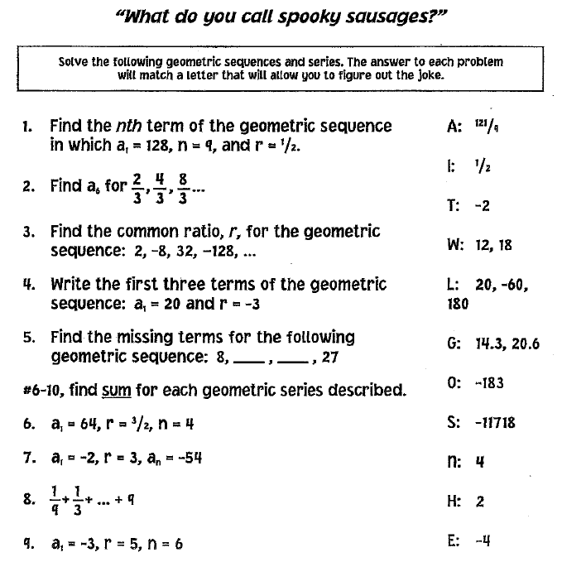

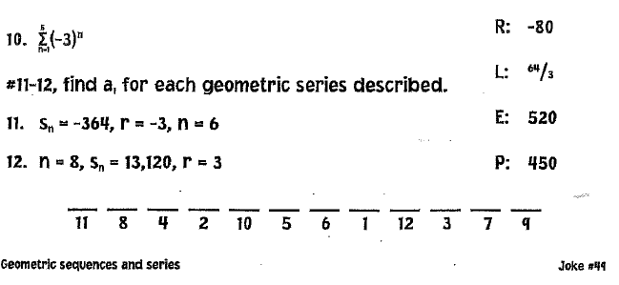

* 1. **Applications of Sequences and Series**

**Example 1:** You visit the Grand Canyon and drop a penny off the edge of a cliff.  The distance the penny will fall is 16 feet the first second, 48 feet the next second, 80 feet the third second, and so on in an arithmetic sequence.  What is the total distance the object will fall in 6 seconds?

**Example 2:** The sum of the interior angles of a triangle is 180º, of a quadrilateral is 360º and of a pentagon is 540º.  Assuming this pattern continues, find the sum of the interior angles of a dodecagon (12 sides).

**Example 3:** After knee surgery, your trainer tells you to return to your jogging program slowly.  He suggests jogging for 12 minutes each day for the first week.  Each week thereafter, he suggests that you increase that time by 6 minutes per day.  How many weeks will it be before you are up to jogging 60 minutes per day?

**Example 4:** You complain that the hot tub in your hotel suite is not hot enough.  The hotel tells you that they will increase the temperature by 10% each hour.  If the current temperature of the hot tub is 75º F, what will be the temperature of the hot tub after 3 hours, to the *nearest tenth* of a degree?

**Example 5:** A culture of bacteria doubles every 2 hours.  If there are 500 bacteria at the beginning, how many bacteria will there be after 24 hours?

**Example 6:** A mine worker discovers an ore sample containing 500 mg of radioactive material.  It is discovered that the radioactive material has a half life of 1 day.  Find the amount of radioactive material in the sample at the beginning of the 7th day.

**Applications of Sequences and Series**

1. A runner begins training by running 5 mi. one week. The second week she runs a total of 6.5 mi. The third week she runs 8 mi. Assume this pattern continues.

* How far will she run in the tenth week?
* At the end of the tenth week, what will be the total distance she has run since she started training?
* Express the total distance with summation notation (Σ).

2. A superball is dropped from a height of 2 m and bounces 90% of its original height on each bounce.

* When it hits the ground for the eighth time, how far has it traveled?
* How high off the floor is the ball at the top of the eighth bounce?

3. A snail is crawling straight up a wall. The first hour it climbs 16 inches, the second hour it climbs 12 inches, and each succeeding hour, it climbs only three-fourths the distance it climbed the previous hour. Assume the pattern continues.

* How far does the snail climb during the seventh hour?
* What is the total distance the snail has climbed in seven hours?
* Express the total distance with summation notation (Σ).

4. Suppose on Jan. 1 you deposit $1.00 in an empty piggy bank. On Jan. 8 you deposit $1.50; on Jan. 15 you deposit $2.00; and each week thereafter you deposit $0.50 more than the previous week.

* What kind of sequence do these deposits generate?
* What amount will you deposit in the 52nd week?
* What is the total in the piggy bank at the end of these 52 weeks?

5. Carla’s Clothing Shop opened eight years ago. The first year she made $3,000 profit. Each year thereafter her profits averaged 50% greater than the previous year.

* How much profit did Carla earn during her 18th year of business?
* What was the total amount of profit Carla earned over her first 18 years?

6. A ball on a pendulum moves 50 cm on its first swing. Each succeeding swing it moves 0.9 the distance of the previous swing.

* Write the first six terms of the sequence generated.
* Assuming the pattern continues, how far will the ball travel before coming to rest?

7. Find the sum of the odd integers from 25 to 75, inclusive.

8. A person just fitted for contact lenses is told to wear them only 2 hours the first day and to increase the amount of time by 20 minutes each day. After how many days will the person be able to wear the contacts for 14 hours?

9. A wooden ladder is wider at the bottom than at the top and has 10 equally spaced rungs (steps). The

bottom rung is 22 inches long and the top rung is 14 inches long. Find the total number of inches of

material used to make all the steps.

10. A post is driven into the ground. The first strike drives the post 30 inches into the ground. The next strike drives the post 27 inches into the ground. Assume these distances form a geometric sequence.

* What is the total distance the post is driven into the ground after 8 strikes (to the nearest inch).
* What is the maximum distance the post could be driven?