AFM Helpful Study Notes for Circular Trig Test

**I. Converting Radians to Degrees or Degrees to Radians**

* If in degrees, multiply by:  (leave in fraction to be exact!)
* If in radians, multiply by: 

**II. To find the length of a circular arc:**

* Formula: **s = r,** where s = arc length, r = radius, and  = angle measure (in radians). So if the problem gives you a degree measure, you must convert to radians.

**III. Coterminal Angles:**

* Add/subtract multiples of  or multiples of 2.

**IV. Reference Angles:**

* Acute angle formed from the terminal side to the *x-*axis. If in degrees, add or subtract 180 or 360 until answer is between 0 and 90.

**V. Unit Circle:**

* **Cos** = “x” values, **Sin** = “y” values, and **Tan** = values. Don’t give a point, if it says exact trig value, then you either give just the x value, y value or y/x value. Be careful with your signs! Pay attention to your quadrants. For secant, cosecant, or cotangent - just reciprocate.
* **A**ll **S**tudents **T**ake **C**lasses 1st Quadrant (All are positive), 2nd quadrant (only Sine is positive),

3rd Quadrant (only Tangent is positive), 4th quadrant (only Cosine is positive).

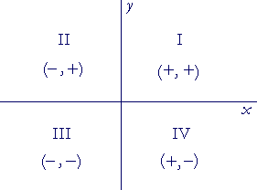

* The main points you need to learn are in the first quadrant because everything is derived from the 1st quadrant.

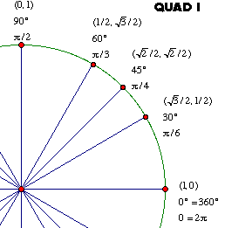

**VI. Graphing y = AsinB(x – C) + D or y = AcosB(x – C) + D**

* Y = sin x graph (goes 0, 1, 0, -1, 0 on a period of 2)
* Y = cos x graph (goes 1, 0, -1, 0, 1 on a period of 2)
* = amplitude
* Period = 
* ‘B’ will match the number of cycles seen within a “normal” period of 2π

Ex. y = 2 sin(3x) You will see 3 cycles of the sine graph from [0, 2π], but the “period” is now 2π/3.

* Phase shift = C: graph shifted left if (x + C) and graph shifted right if (x – C)
* Vertical shift = D: graph shifted UP if **+D** and graph shifted DOWN if **- D**

**VII. Sinusoidal Applications – getting sine or cosine equations to model application**

From information given, plot the max, min, and x-intercepts (or if there is a vertical shift, draw in the “midline” – halfway between max and min and plot intercepts with the midline). Remember, Amplitude

A= ½(max – min), Vertical shift is midline (if there is one), period = length on x-axis of one cycle and then B = , to find any phase shift – find where the “normal” sine or cosine curve would start (x-intercept for sine or max for cosine).