**Geometric Probability**

1. A game at the state fair has a circular target with a radius of 10.7 cm on a square board measuring 30 cm on a side. Players win prizes if they throw a dart and hit the circular area only.
2. What is the probability of a player winning with one dart?
3. Suppose a player gets 3 darts to play. What is the probability that the player will land in the circle area all three times?
4. What is the probability that the player misses all 3 times?
5. What is the probability that the player lands in the circular area at least one time?

2. If a dart randomly hits the board, what is the probability that it will hit in region II?

A.  B. C. D. 

I

II

IV

III

10”

30”

15”

10”

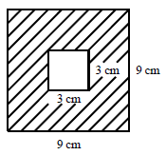

1. Find the probability of landing in the shaded region above.
2. Use the following dart board to answer the questions below:

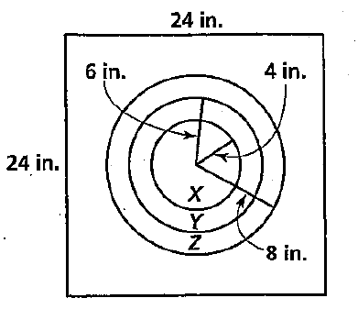

* 1. If a dart hits the board, find the probability that it will land in region X
  2. If a dart hits the board, find the probability that it will land in region Z
  3. If a dart hits the board, find the probability that it will NOT hit any of the circles.

Binomial Probability/Expansions:

Expand the following:

1. (x + y)5 2. (x2+3)6

1. What is the coefficient of the x3y7 term in the expansion of (x + y)10?

4. In a history class, Colin is taking a multiple choice quiz. There are 10 questions and each question has five possible answers. What is the probability that

1. Colin will get exactly 8 questions right if he guesses on each question.
2. Diana will get exactly 8 questions right if she studies so that she has a 75% chance of answering each question correctly.

5. The probability that an egg is cracked is 3%. If you buy two dozen eggs, what is the probability that

1. none of your eggs are cracked
2. at least one of your eggs is cracked
3. exactly two of your eggs are cracked

6. A pair of dice is rolled 20 times. What is the probability that a sum of 5 is rolled

1. exactly 6 times
2. exactly 12 times
3. at most 2 times