**H. Math 3 Final Exam Specs/Formulas**  Name __________________________________

Topics may include, but not limited to:

* Linear Programming – identifying objective function and constraints
* Factoring completely (GCF 1st, difference of squares, sign rules, slide and divide, etc)
* Identify focus and directrix of parabola
* Converting quadratic function from standard to vertex form
* Solving quadratics using graph, by factoring, completing square, and quadratic formula (remember zeros, roots, solutions all mean the same)
* Simplifying complex numbers
* Complete the square to solve or put in vertex form (or standard form for circles)
* Determining if a binomial is a factor using remainder theorem
* Simplifying polynomials (adding, subtracting, multiplying)
* Long Division/Synthetic Division
* Graphs of polynomial functions (relative and absolute min/max; increasing/decreasing; behavior at roots and ends)
* Simplifying, multiplying, dividing, adding, and subtracting rational expressions
* Vertical and Horizontal Asymptotes
* Solving rational equations
* Solving for angles in circles (central, inscribed, outside angles)
* Solving for angles in quadrilateral inscribed in a circle
* Converting equation of a circle from general to standard form; identify center and radius
* Converting from degrees to radians; radians to degrees
* The Unit Circle! Make sure you can identify exact values of sin, cos, and tan using unit circle
* Using properties of logarithms to expand or condense
* Solving logarithmic and exponential equations
* Find the nth term of a sequence
* Find the sum of a series
* Functions – domain, range, compositions, inverses

**Quadratics and Polynomials**

Standard form of a quadratic: 

Addition: $\left(f+g\right)\left(x\right)=f\left(x\right)+g(x)$

Subtraction: $\left(f-g\right)\left(x\right)=f\left(x\right)-g(x)$

Multiplication: $\left(f∙g\right)\left(x\right)=f(x)∙g(x)$

Division: $\left(\frac{f}{g}\right)\left(x\right)=\frac{f(x)}{g(x)}, g(x)≠0$

Composition: $(g∘f)\left(x\right)=g(f\left(x\right))$

Vertex form: 

Intercept form: 

Axis of Symmetry: 

(you can also find the **x-coordinate of the vertex** with this formula)

Complete the square: 

Quadratic Formula:  Discriminant:  Complex #’s: , 

Factoring difference of squares: 

Sum/Difference of cubes: ** and **

Focus and Directrix:

The focus lies on the axis of the symmetry of the parabola at the point , with  .

The directrix is a horizontal line on the side of the vertex opposite of the focus, given by the equation 

** are the coordinates of the vertex of the parabola

**Rational Expressions and Functions**

Inverse Variation:  Constant of Variation: k = xy

To **simplify a multiplication problem**, first *factor* all of the numerators and denominators as much as you can. Next, cancel out where possible – one on the top and one on the bottom. Whatever is left and un-cancelled is the answer.

To **simplify a division problem**, Keep:Change: Flip! Flip the second fraction and change the problem to multiplication, then do it like in the Hint above.

**Solving a rational equation**: If fraction = fraction, cross multiply and solve for x. If more than one fraction on a side, find LCD of all denominators and multiply through to cancel denominators.

**Circles**

**Central angle:** an angle whose vertex is the center of the circle. It is equal to the arc it forms.

**Arc:** part of a circle’s circumference (the crust of a slice of pizza)

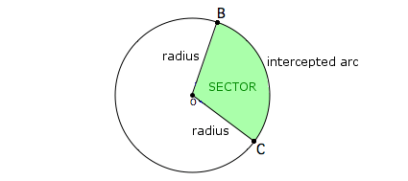

**Sector:** region bounded by an arc of the circle and the two radii

to the arc’s endpoints. (slice of pizza)

**Tangent**: a line in the plane of a circle that intersects the circle in exactly one point. Forms 90 degree angles with radius of circle.

**Chord:** a segment whose endpoints are on a circle

**Secant:** a line that intersects a circle at two points.

Circumference of a Circle:  *or* 

Area of a Circle: 

Arc length (in radians):  (where s is arc length, ris the radius of the circle and  is the angle)

Area of a Sector (in radians): A =

Central angle: 

Inscribed angle: 

The measure of an angle formed by a tangent and a chord:  (whereis the arc formed by angle)

Outside angle: 

**Opposite angles of an inscribed quadrilateral are supplementary.

**

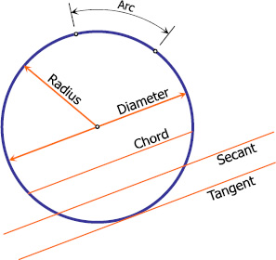

Equation of a Circle with center at (h, k) – standard form: 

**Unit Circle**

Convert degrees to radians: Convert radians to degrees:

Sine:  Cosine: 

***Amplitude:*** half the difference between the max and min values of the function

***Period:*** horizontal length of one cycle, where one cycle ends OR use formula: 

|  |  |
| --- | --- |
| ***Sine Curve-starts at 0*** | ***Cosine Curve-starts at 1*** |
|  |  |

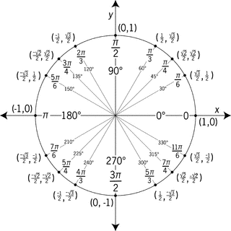

**Trigonometric Identities**

**Reciprocal Identities** (csc = cosecant, sec = secant, cot = cotangent) **Tangent and Cotangent Identities**

   ** **

**Pythagorean Identities**

  

  

  

**Sequences and Series**

|  |  |  |  |  |
| --- | --- | --- | --- | --- |
| **a1 = first term, n = # of term, d = common difference, r = common ratio, an = nth term** | | | | |
| Arithmetic Sequence  A(n) = a1 + (n – 1 ) d | Geometric Sequence  A(n) = a1 ⋅ rn-1 | Finite Arithmetic Series | Finite Geometric Series | Infinite Geometric Series  , |

**Exponential and Log Functions**

Changing to/from exponential and log forms: If , then .

Exponential Equation: 

Exponential Growth:  Decay: 

Continuously Compounded: 

**Non**-continuously Compounded: 

*n = # of times compounded (monthly = 12, quarterly=4)*

**Log Properties (also used with natural logs)**

Product Property: 

Quotient Property: 

Power Property: 

**Other Hints/Tips**

1. Any time you are asked to **solve** an equation or list the **solutions** to an equation, plug in the choices for X on your calculator (# STO> X) and then plug them into the equation. The left side and the right side have to come out equal to each other! You can plug in real numbers or imaginary numbers (using the *i* button on your calculator).
2. The word “**zeros**” means the same thing as “solutions.” Finding the zeros of a function is the same as setting it equal to 0 and solving for X, so this is like the Hint above. **Zeros** that are real numbers (without an *i*) are the same as the x-intercepts on the graph. So, to find the zeros, you can also put the function in as Y= on your calculator, graph, and see where it hits the x-axis.
3. The **number of roots** of an equation is equal to its degree (the highest exponent). For example, if an equation is cubed, then you know it has three roots. The number of real roots and the number of imaginary roots must add up to this number. So, for example, if a cubed equation crosses the x-axis only once, that means it has only one real root, so it must have two imaginary roots (you can’t see these on the graph), since 1+2=3.
4. To calculate the **value of a logarithm** with its base something other than 10, type it in like this: log(the number) / log(the base). For example, would be typed in as , which is equal to about 2.63.
5. To see if a binomial (for example, x – 4) is a **factor** of something, you can do one of these two things: (i) use synthetic division to see if the remainder is zero, or (ii) graph it to see if +4 is one of the x-intercepts.
6. The Last One! Any problem that involves **simplifying a complicated algebra problem** can be figured out by plugging in values for the letters. For example, to simplify one of those crazy factoring/multiplication/division/log problems, you could plug in something for x (like x=2), work out the original problem and the four choices, and then see which ones match. This takes a while, but it is guaranteed to work every time!