**Math 3-Formula Sheet**

**Transformations**

|  |  |
| --- | --- |
| *Function* | *Form* |
| Quadratic |  |
| Absolute Value |  |
| Exponential |  |
| Radical |  |
| Logarithm |  |
| Sine/Cosine |  |
| Inverse Variation |  |

|  |  |  |  |
| --- | --- | --- | --- |
| *Vertical Shifts (k)* | | *Horizontal Shifts (h)* | |
| +k | *up* | +h | *left* |
| -k | *down* | -h | *right* |

**Statistics**

To find the MEAN, MAXIMUM, MINIMUM, Q3, Q1, and STANDARD DEVIATION of a set of data:

1. Press STAT, ENTER (to enter your data) – Put it in L1
2. Press STAT
3. 🡪 To Calc
4. Press 1, ENTER *= mean, = standard deviation, n = # of values in the data, Med = median*

***Random Sample***-lottery method (everyone has an equally likely chance to be chosen)

***Convenience Sample***- easy to reach (poll people in the lunchroom)

***Systematic***-Example: want 150 students, 1800 students names are put in the list, choose the 8th person, then every 12th (because 1800/150=12) after that until 150 are chosen.

***Stratified***- Subgroups- a desired number is chosen from EACH subgroup. (Ex: Fresh, Soph, Jun, Sen-100 chosen from all)

***Cluster***-counties- all people in chosen counties participate, none of the people in non-chosen counties participate.

***Self-Selected***- person chooses to participate (online survey)

***Survey***-questionnaire

***Experiment***-used to prove cause and effect; controlled (1) how subjects are assigned to groups, and (2) which treatments each received

***Observational Study***- researcher CANNOT control (1) and/or (2) (*from above definition of experiment*)

**Geometry**

Parallel Lines and Transversals

* Angles that are congruent: corresponding, alternate-interior, vertical
* Angles that are supplementary (add up to 180 degrees): Same-side interior

Triangle congruency: SSS, SAS, ASA, AAS

Other “reasons” used: CPCTC (Corresponding parts of congruent triangles are congruent)-used after triangles are proven congruent, Reflexive

Properties for Parallelograms:

* *Opposite sides of a parallelogram are congruent.*
* *Opposite angles of a parallelogram are congruent.*
* *The diagonals of a parallelogram bisect each other.*

Points of Concurrency

When 3 or more lines intersect in one point, they are ***concurrent***. The point at which they intersect is the ***point of concurrency***.

The point of concurrency of the perpendicular bisectors of a triangle is called the ***circumcenter of the triangle***.

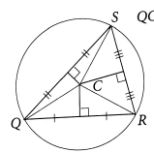

*(Circumcenter - bisector)*

The point of concurrency of the angle bisectors of a triangle is called the ***incenter of the triangle***.

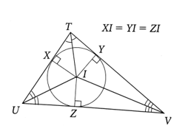

*(Incenter - bisector)*

In a triangle, the point of concurrency of the medians is the ***centroid***. (which is point C below)

*(Centroid -median)*

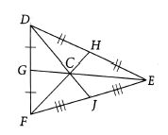

|  |  |
| --- | --- |
| Distance Formula: | Midpoint Formula: |

**Polynomials**

Standard form of a quadratic: 

Vertex form:  **(h, k) is vertex**

Axis of Symmetry:  (you can also find the **x-coordinate of the vertex** with this formula)

Complete the square:  Quadratic Formula:  Complex #’s: 

Equation of a Circle with center at (h, k): 

**Rational Expressions and Functions**

Inverse Variation:  Constant of Variation: k = xy

**Exponential and Log Functions**

Inverse: Switch x and y (solve for y)

Exponential Equation: 

Exponential Growth:  Decay: 

Continuously Compounded: 

**Non**-continuously Compounded: 

*n = # of times compounded (monthly = 12, quarterly = 4)*

* Base of the log = base of the power
* Across from equals sign is the exponent

Changing to/from exponential and log forms: If , then .

**Log Properties (also used with natural logs)**

Product Property:  Quotient Property: 

Power Property: 

**Unit Circle**

Convert degrees to radians: Convert radians to degrees:

Sine:  Cosine: 

***Amplitude:*** half the difference between the max and min values of the function

***Period:*** horizontal length of one cycle, where one cycle ends OR use formula: , b is the # of cycles from 0 to 2π

|  |  |
| --- | --- |
| ***Sine Curve-starts at 0*** | ***Cosine Curve-starts at 1*** |
|  |  |

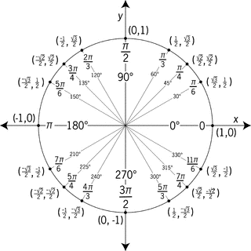

**Circles**

***Central angle*:**  *an angle whose vertex is the center of the circle.* It is equal to the arc it forms.

***Arc*:** *part of a circle’s circumference* (the crust of a slice of pizza)

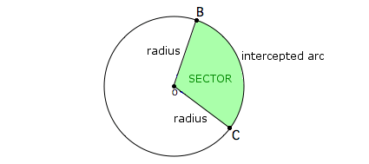

***Sector*:** *region bounded by an arc of the circle and the two radii*

*to the arc’s endpoints.* (slice of pizza)

***Tangent***: *a line in the plane of a circle that intersects the circle in exactly one point.* Forms 90 degree angles with radius of circle.

***Chord*:** *a segment whose endpoints are on a circle*

***Secant:*** *a line that intersects a circle at two points. A secant also does NOT pass through the center of a circle.*

Circumference of a Circle:  *or* 

Area of a Circle: 

Arc Length (in degrees): 

Arc length (in radians):  (where s is arc length, ris the radius of the circle and  is the angle)

Area of a Sector: 

Inscribed angle:  (where is the intercepted arc)

The measure of an angle formed by a tangent and a chord:  (whereis the arc formed by angle)

