Parent Functions

Graph each of the following functions. Use the table to help you come up with quality graphs! Label **at least 3 points** on your graph. THESE are graphs of functions that you will need to KNOW and be able to reproduce without help of a calculator!!

1. f(x) = x 2) f(x) = x2 3) f(x) = 

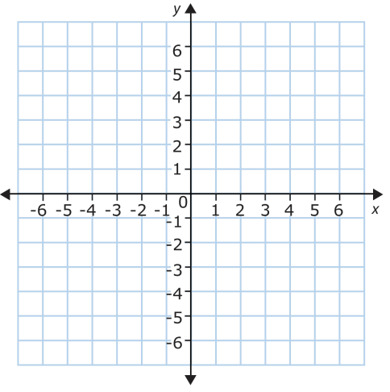  

Domain:_____________________ Domain:_____________________ Domain:_____________________

Range:______________________ Range:______________________ Range:______________________

Symmetry:__________________ Symmetry:_________________ Symmetry:__________________

4) f(x) = x3 5) f(x) =  6) f(x) = 2x

  

Domain:_____________________ Domain:_____________________ Domain:_____________________

Range:______________________ Range:______________________ Range:______________________

Symmetry:__________________ Symmetry:_________________ Symmetry:__________________