AFM Review for Test: Name ________________________

Review for Unit 1 Piecewise Functions Test

* Be able to look at a graph and state the domain and range, increasing, decreasing, and constant in interval notation.
* Know when to use parenthesis versus brackets. Recall: always use parenthesis around infinity or negative infinity because we don’t know the exact value of infinity. We use brackets when we know the value and we know it can equal that value. If there is an open circle on the endpoint of a graph, use parenthesis at that number because the graph goes up to that number but not including. Increasing/decreasing is ALWAYS parentheses.
* Be able to determine domain given an equation and write in interval notation. **Special problems are fractions and even roots**
* Be able to evaluate function values given graph or equation (including piecewise).
* Be able to graph piecewise functions.
* Be able to set up piecewise functions from a word problem. Be able to graph it and answer questions regarding the word problem. Including step functions indicated by “any part of” or similar phrase.
* Do the following for extra help! Do all your work on another sheet of paper!

1. Do problems in book (2nd edition): p283-284 #1, 3(a-d)-5, 7-11, 21-24, 29-32, 47a-g, 48 (not e)
2. Find the domain of the following:
3.  b)  c)  d) 

3. Graph the following piece wise functions. Then, state the domain, range, where it is increasing, decreasing, constant. Write in interval notation.

a) f(x) =  b) f(x) = c) f(x) = 

4. Use the following graph to evaluate certain values and to find out when it is increasing and decreasing. Also, state the domain and range.



a) f(2) = _______ Increases: ____________________

b) f( 4) = _______ Decreases: ____________________

c) f(0) = _______ Domain: ______________________

d) f(x) = 0 when x = ______ Range: _______________________

e) f(x) = -3 when x = ______

**Be able to set up piece-wise functions and answer questions based on them.**

5. A freight company charges $1000 for up to 54 cubic feet of material being shipped. They charge an additional $400 for every additional 27 cubic feet or part thereof. Express the cost to ship C(v) as a function of volume v as a piecewise function. How much does it cost to ship 30 cubic feet? 100? 400? Graph the function.

6. A T-shirt printing company, Custom T-shirts, charges a set up fee for each order, plus the cost per shirt. If you buy less than 20 shirts, it costs a set up fee of $10 then $10 per shirt. The company reduces the price to $8 per shirt, after the first 20 are purchased up to 100 shirts. Then, they will reduce the price to $4 per shirt, after the first 100 are purchased.

1. Express *C*, the total cost in dollars, as a piecewise function of *n*, the number of shirts ordered.
2. How much does it cost for 15 shirts? 25 shirts? 150 shirts?
3. Graph the function.

Answers to Study Guide: (For textbook answers, see back of book)

2a.  b. (-∞, 2] c. (-∞, ∞) d. [-2, 1) U (1,∞)

3a. Domain: (-2, ∞), Range: (-6, ∞), Inc (-2, 1) ∪ (1, ∞), Dec: none, Constant: none

. 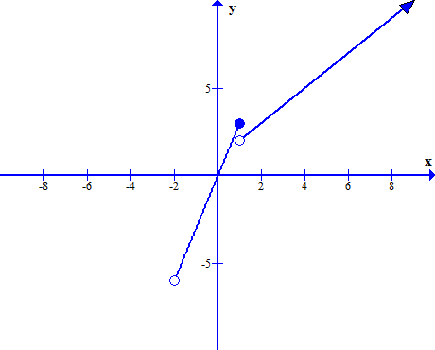 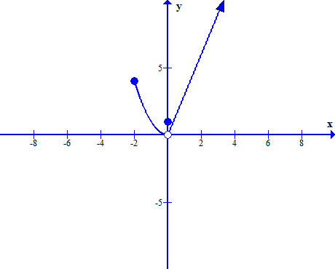

3b. Domain: [-2, ∞), Range: (0, ∞), Inc (0, ∞), Dec: (-2, 0), Constant: none

3c. 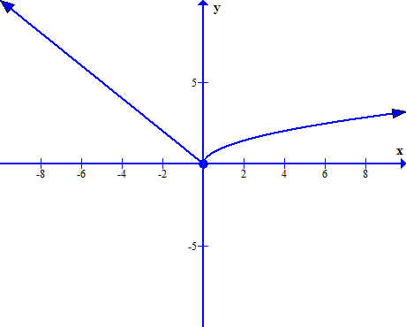 Domain: (-,∞ ∞), Range: [0, ∞), Inc (0, ∞), Dec: (-∞, 0), Constant: none

4a. 0 4b. -3 4c. 2 4d. -2, 2 4e. 4 4. inc: (-∞, 0) 4. dec (0, ∞)

4. domain: (-∞,∞) 4. range: (-∞, 2)

5. This is a step function:

C(v) = 1000 if 0 < v ≤ 54

1400 if 54 < v ≤ 81

1800 if 81 < v ≤ 108

2200 if 108 < v ≤ 135

Etc…

30 cubic feet = $1000, 100 cubic feet = $1800, 400 cubic feet = $6200

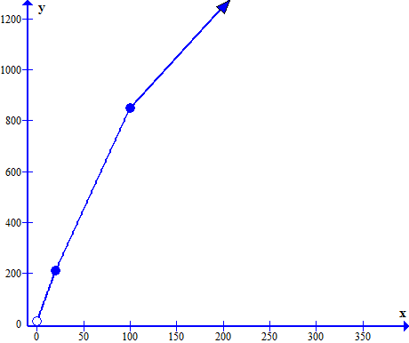

6. NOT a step function:

C(n) = 10 + 10n if 0 < n ≤ 20

210 + 8 (n – 20) if 20 < n ≤ 100

850 + 4(n – 100) if n > 100

b. 15 shirts = $160, 25 shirts = $250, 150 shirts = $1050

c. x-axis = number of shirts, y-axis = cost, title Custom Shirts