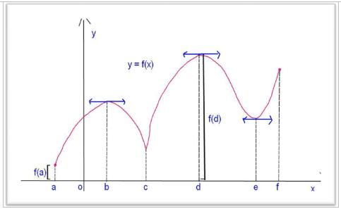

1. For the above graph, determine the following:

Critical numbers:________________________________

Absolute Maximum Value:_______________ Absolute Minimum Value:_______________

x-values of local minima: _______________ x-values of local maxima: _______________

:______________________ does not exist: ___________________

Intervals where f(x) is increasing:_________________________________

Intervals where f(x) is decreasing:_________________________________

1. Determine the **critical numbers** of 
2. Determine the **absolute extreme values** of on [-2, 3].